Templates for title page:
Visit mycampus.hslu.ch
-> Info for Students -> Bachelor -> Bachelor’s and Master’s thesis

Templates for declaration of independently created work
-> Info for Students -> Bachelor -> Bachelor’s and Master’s thesis -> Implementation Guidelines

Must be submitted separately

Preface
(optional)
„Personal experiences with or thoughts about the thesis or thesis process can be written in the preface. For example:
- Thoughts about encountering the subject of investigation (topic, people, etc.)
- Personal experiences with the subject of investigation
- Generalization: classification of the subject into a wider context
[…]
- Acknowledgements” (Ineichen, 2010, p. 10).

This is an optional part of a dissertation which should not include the scientific or academic discussion of the topic. This is rather the place to include personal comments. These may be, for example, on:
• your choice of subject
• the place of your subject in your field of study
• your experiences during the process of producing your work
• the thanks you wish to express to those who have helped you (Millar, 2012, p. 7f.)

Table of contents
List of figures 5
List of tables 6
List of abbreviations and acronyms 7
1 Introduction 8
1.1 Starting situation 8
1.2 Research problem 8
1.3 Research objective 8
1.4 Structure of the thesis 8
2 Foundations 9
2.1 Foundations 2.1 9
2.2 Foundations 2.2 9
2.3 Interim conclusion 9
3 Methodology 10
3.1 Methodology 3.1 10
3.2 Methodology 3.2 10
3.3 Interim conclusion 10
4 Implementation 11
4.1 Implementation 5.1 11
4.2 Implementation 5.2 11
4.3 Interim conclusion 12
5 Results 13
5.1 Results 6.1 13
5.2 Results 6.2 13
5.3 Interim conclusion 13
6 Discussion 14
6.1 Discussion 7.1 14
6.2 Discussion 7.2 14
6.3 Interim conclusion 14
7 Final considerations and outlook 15
7.1 Summary of the results 15
7.2 Recommendations for the company 15
7.3 Future need for research 15
Bibliography 16
Appendix 17

List of figures
(optional)
Figure 1: TextTextText. 3
Figure 2: TextTextText 3

List of tables
(optional)
Table 1: TextTextText 3

List of abbreviations and acronyms
Abbreviations and acronyms can be used freely once the full form or proper name has been established.
HSLU | Hochschule Luzern
Lucerne UASA | Lucerne University of Applied Sciences and Arts

Introduction

Starting situation

Research problem

Research objective

Structure of the thesis

Foundations
„The foundations chapter informs about the current state of knowledge on which the thesis is based. Definitions, models and references to other scientific work and research results are part of this chapter“ (Ineichen, 2010, p. 12).
The chapter Foundations is based on a detailed literature research. It has to be taken into account that in general, publications from scientific journals have a higher credibility than other sources.

Your literature review should not be exhaustive, but rather authoritative. In other words, you should review the most important relevant work of others, the so-called core texts, and show that you have made use of the most pertinent desk-based sources. If you are reviewing the work of others, concentrate on their findings and conclusions, and any interesting methodological comparisons between their approach and yours. If you are detailing desk-based sources, then show in what way they are useful and make any necessary comments on their limitations (Millar, 2012, p. 8f.).

Foundations 2.1
(title needs to be adjusted)

Foundations 2.2
(title needs to be adjusted)

Interim conclusion

Methodology
„In this section, the research approach and the underlying methodology (qualitative, quantitative methods) are described. If different research approaches are possible, the choice should be justified.
This chapter shall, for example, include considerations about the necessity of a survey, the creation of a questionnaire as well as the choice of the sample.” (Ineichen, 2010, p. 12).

If your study involves a piece of interview-based or qualitative research, you should explain the questions you put, the selection of your sample of interview partners, and the analytical methods you intend to use. If, on the other hand, you are doing a quantitative survey, you should describe the survey instrument you used (e.g. the questionnaire), the size of the sample taken and the statistical methods you intend to apply.
With any method you describe you should include a brief discussion of its advantages and drawbacks. It is vital that your dissertation does not make claims or reach conclusions which go beyond what your methods and especially your sample warrant (Miller, 2012, p. 9).

Methodology 3.1
(title needs to be adjusted)

Methodology 3.2
(title needs to be adjusted)

Interim conclusion

Implementation
(Title can be adjusted. Example: Analysis)
„Here the analytical and conceptual investigation of the research questions is described. Depending on the topic, the length and grade of differentiation may vary” (Ineichen, 2010, p. 12).

Implementation 5.1
(optional; title needs to be adjusted)
Sample table and reference:
Group 1 | Group 2 | Group 3
Table 1: TextTextText

Implementation 5.2
(optional; title needs to be adjusted)
Sample figures:
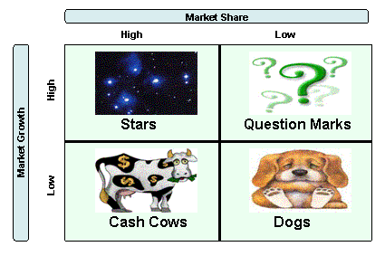
Figure 1: TextTextText.
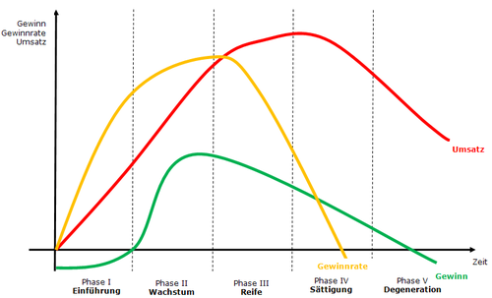
Figure 2: TextTextText

Interim conclusion

Results
(optional)
„In this chapter the results of the thesis are presented. It can be helpful to visualize the results with tables, diagrams, etc. Papers with practical orientation may also present and comment on measures to take and alternatives to be considered“ (Ineichen, 2010, p. 12).

In this section you should give the results of your research in such a way that they are clear and easily grasped overall by the reader. Tables, charts and other diagrammatic figures may help in achieving this. These should always be referred to and commented on in the text. Generally your results should be given in sufficient detail to support your conclusions (Millar, 2012, p. 9).

Results 6.1
(optional; title needs to be adjusted)

Results 6.2
(optional; title needs to be adjusted)

Interim conclusion

Discussion
(optional)

Discussion 7.1
(optional; title needs to be adjusted)

Discussion 7.2
(optional; title needs to be adjusted)

Interim conclusion

Final considerations and outlook

Summary of the results

Recommendations for the company

Future need for research

Bibliography
Backhaus, K. (2003). Industriegütermarketing (7. ed.). München: Verlag Vahlen.
Ineichen, M. (2010). Wissenschaftliche Arbeiten konstruieren und gliedern (Eulenskript). Luzern: Hochschule Luzern Wirtschaft.

Appendix
„The appendix shall contain all supplementary tables and references significant for the comprehensibility and foundation of the thesis. For example, when surveys are part of the thesis, the detailed tables from survey results or a questionnaire with summarized results would be included here.
The main text shall, at the appropriate places, contain references to the appendix“ (Ineichen, 2010, p. 17).

